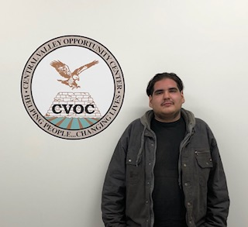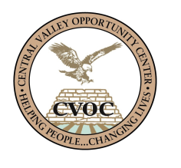

**“CVOC changed my life, they gave me the opportunity to start my Welding career.”**

Saibien Rosalez and his younger sister were raised and cared by his paternal grandmother, Josefina Magana. Mrs. Magana worked for SENECA sorting fruit on a seasonal basis for over 30 years until the company was permanentely closed in 2017.

She came in direct contact with CVOC during the rapid response process where information and presentations were conducted by us, Central Valley Opportunity Center, Emloyment Development Department (EDD), Teamsters Union and other agencies. After listening to the information she immediately became interested in getting information for her grandson, Saibien, who at that time was still in high school.

Soon after high school, Saibien called to set up an appointment and start the eligiblilty and assessment process. Mrs. Josefina Magana claimed both her grandchildren as dependents which made Saibien eligibile for training services. He expressed interest in becoming a welder because he had heard it was fairly easy to find employment as a welder. His goal was to earn money and helped out his grandmother with the household expenses.

Saibien’s eligibility and assessment process started July 18th, 2018 and class room training begun August 6th, 2018. Training was successfully completed Friday , January 25th, 2019. His first day of employment was the following Monday, January 28th, 2019. He’s now working full time as a welder making $14.50 an hour with Dragon Products.

**Saibien Rosalez**

**Welding and Industrial Maintenance**