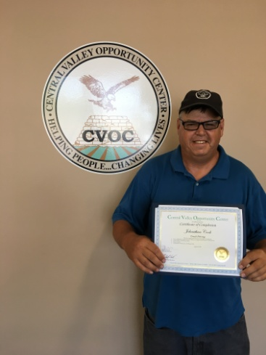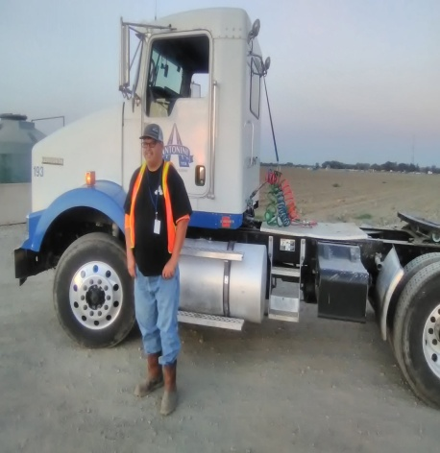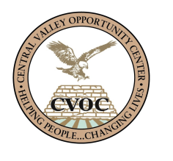

## Johnathan was walking one day thru the parking lot where CVOC is located. He came into the office to inquire more about CVOC’s free vocational training. He was interested in getting into the truck driving training because there were a lot of open positions in this field and with good pay. He saw CVOC as an opportunity to change his financial and living situation. He had recently lost his job in December of 2017 because his car broke down and did not have the income to be able to fix it. This also caused him to end up homeless. Fortunately, he was allowed to stay at the Modesto Gospel Mission for shelter until he was able to complete his training at CVOC and get back up on his feet.

## Johnathan was enrolled under the CSBG/CSP program on April 30th, 2018. Johnathan completed the training three months after on August 8th, 2018. It was a challenge for him to get his Class A license because he had never drove trucks in his life. He did not pass his DMV driving test the first or second time, but succeeded on his third try. He was exited when he passed his driving test and was able to obtain his Class A license. A few days after, he got a job with Antonini Freight Express on August 25th 2018, making $15.00 dollars per hour and working more than 55 hours per week. He is going to continue working with Antonini through out the tomato and almond season. After this, he is going to be working with the company year-round plus benefits hauling wine. According to Johnathan “CVOC made it possible for me to have employment and has changed my life. Now with this job, I will be able to afford a place to live in and a car to drive to work.” He is really exited of his accomplishment and has referred other people to CVOC so they can change their live too.

**Johnathan S. Cook**

**“CVOC made it possible for me to have employment and has changed my life”**

Johnathan S. Cook

Class A Truck Driver